1. to find all employees

select \* from emp;

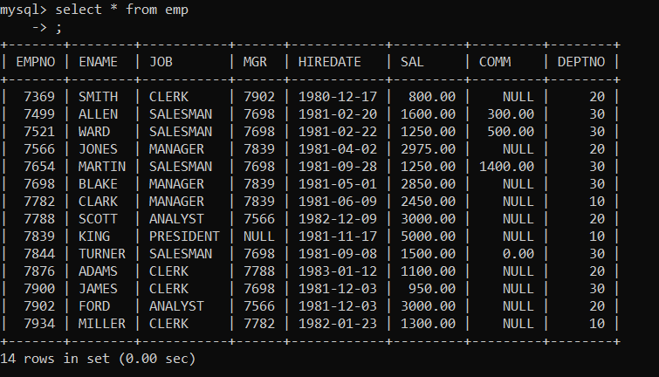

2. to find all departments

select \* from dept;

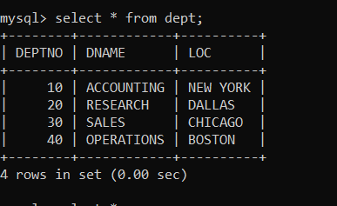

3.to find all employees working in dept 10

select \*

from emp

where deptno=10;

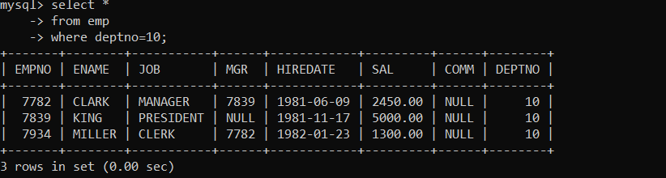

4. to find all employees with job CLERK

select \*

from emp

where job='CLERK';

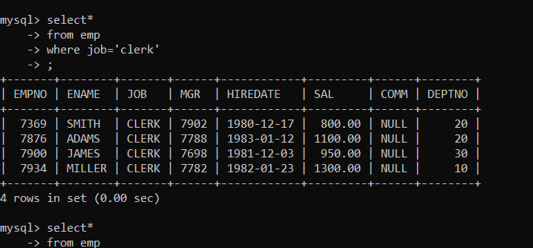

5. to find all employees who joined on 1981-02-22

in oracle date format 22-FEB-1981

in mysql date format

select \*

from emp

where hiredate='1981-02-22';

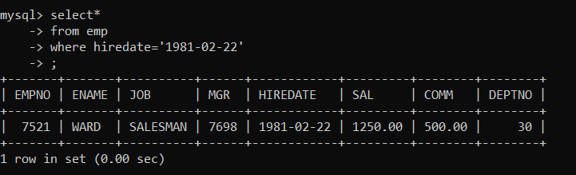

To combine conditions

(using and, or, not)

6. to find all employees with sal >1500

and work in department 30

select \*

from emp

where sal >1500 and deptno=30;

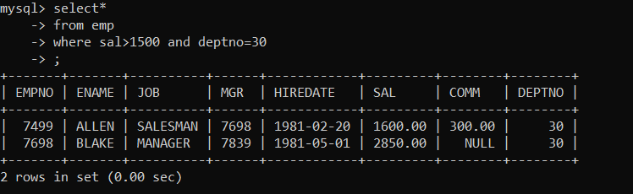

7. to find all employees with sal >1500

and work in department 30

select \*

-> from emp

-> where sal >1500 or deptno=30;

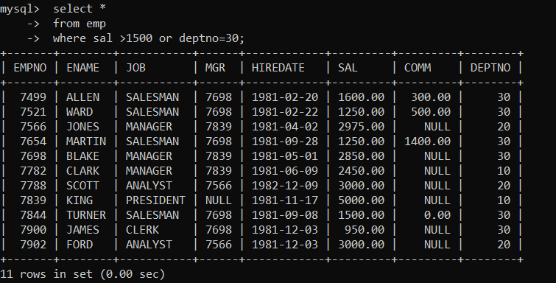

8. to find all employees working in either

deptno 20 or deptno 30

select \*

from emp

where deptno=20 or deptno=30;

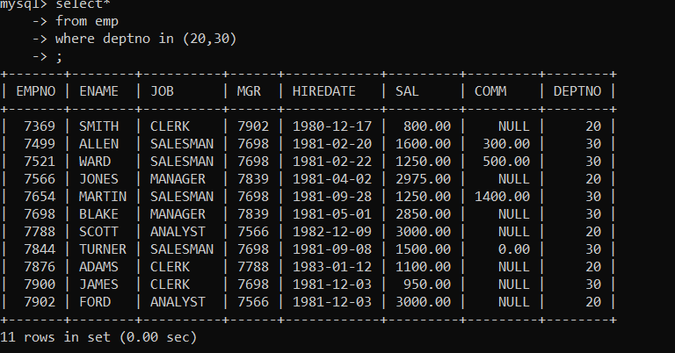

In operator

select \*

from emp

where deptno in (20,30);

9. to find all employees with

sal either 800 or 1600 or 1250

select \*

from emp

where sal in (800,1600,1250)

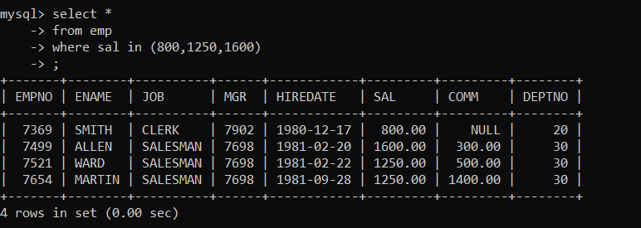

10. find all employees who have joined

on either 1980-12-17 or 1981-05-01

select \*

from emp

where hiredate in ('1980-12-17','1981-05-01');

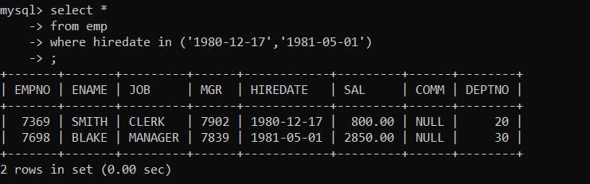

11. to find all employees with sal >=1600 and <=5000;

select \*

from emp

where sal >=1600 and sal<=5000;

between....and --- to check the range of values

select \*

from emp

where sal between 1600 and 5000

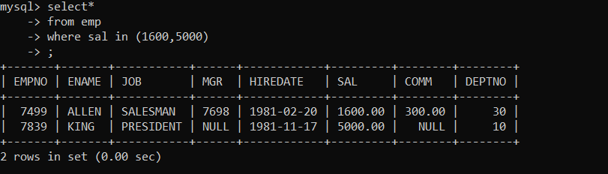

12. to find all employees with sal <=1600 or >=5000;

select \*

from emp

where not between 1600 and 5000;

between....and --- to check the range of values

select \*

from emp

where sal between 1600 and 5000;

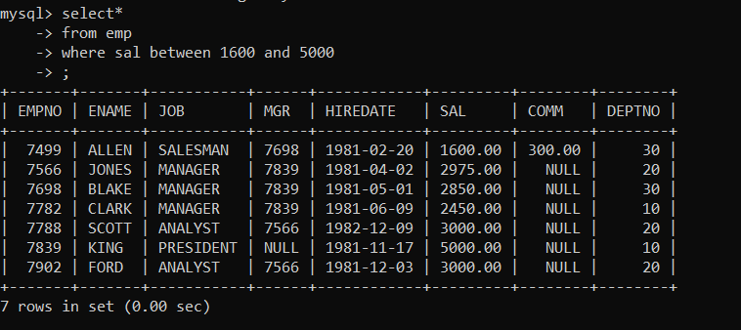

12. to find all employees who joined in year 1981

select \*

from emp

where hiredate between '1981-01-01' and '1981-12-31';

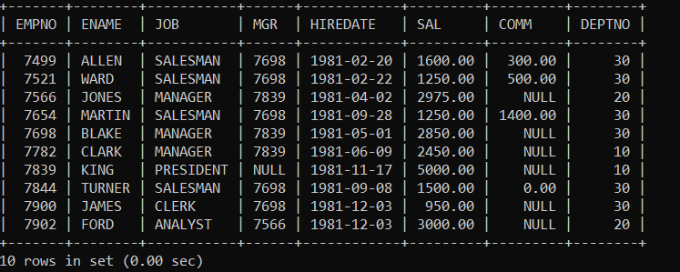

13. to find all employees who are not working in

dept 10 or 20

select \*

from emp

where deptno not in (10,20);

